|  |  |
| --- | --- |
| **Name** | **Student ID Number** |
| Do Nhat Anh Ha | 1194034 |

**Question 1:**

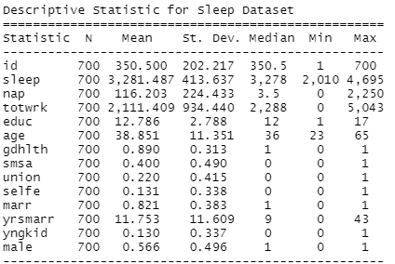

Based on the sample means, a typical individual is around 39 years of age, sleeps for 3281 minutes (overnight) per week with napping time of 116 minutes per week, works for a total of 934 minutes per week, has 12.8 years of education attainment, has self-reported health as “Excellent” or “Good” 90% of the time, lives in a US urban area 40% of the time, is part of a union 22% of the time, is self-employed 13.1% of the time, is married 82.1% of the time, is married for 11.7 years, has kid below 3 years old for 13% of the time, and is a male for 57% of the time.